Cairo University Faculty of Computers and Information



**CS352 – Software Engineering II**

**Phase 2 Template**

**2017**

**Staff:**

**Dr Amr Kamel** [a.kamel@fci-cu.edu.eg](mailto:a.kamel@fci-cu.edu.eg)

**Dr Khadiga Mohamed kelbedweihy@fci-cu.edu.eg**

**TA: Ragia Mohamed Aboulfadl**

**TAs: Eng Mohamed Samir m.samir@fci-cu.edu.eg**

**Eng Omar Khaled Ali Ragab o.khaled@fci-cu.edu.eg**

**Eng Ragia Mohamed r.mohamed@fci-cu.edu.eg**

**Eng Ebtehal yahia ebtehal.yahia@fci-cu.edu.eg**

**Eng Ahmed Emad ahmed.emad@fci-cu.edu.eg**

**Eng Amr Tarek a.tarek@fci.cu.edu.eg**

# Project Team

|  |  |  |  |
| --- | --- | --- | --- |
| ID | Name | Email | Mobile |
| 20140066 | Alaa Atef Badr | [alaa.badr.25@gmail.com](mailto:alaa.badr.25@gmail.com) | 01140911255 |
| 20140062 | Ismail Ahmed Mahmoud | [ismail.ahmed2014@stud.fci-cu.edu.eg](mailto:ismail.ahmed2014@stud.fci-cu.edu.eg) | 01005887976 |
| 20140206 | Karim Ehab Ahmed | [karimehabahmed@stud.fci-cu.edu.eg](mailto:karimehabahmed@stud.fci-cu.edu.eg) | 01062064070 |
| 20140274 | Mostafa Mohamed ElMenshawy | [mustafa1elmenshawy@gmail.com](mailto:mustafa1elmenshawy@gmail.com) | 01148504856 |

Contents

Project Team 2

Your Restful API 3

User Services 4

Login: 4

Register Student: 4

Register Teacher: 5

Course Services 6

Show Courses 6

Show Teacher Courses: 8

Show Student Courses: 9

Get Course: 10

Add Course: 11

Enroll Student: 12

Get Unenrolled Courses: 12

Game Services 13

Get Game 13

Add game 15

Get Games of Course: 16

Level Services 18

Get Level 18

Get Levels 19

Add Level 20

Achievement Services 21

Show Achievements 21

Add achievements 24

Class diagram design 26

Subsystems 26

Achievement 27

Course 28

Game 29

Level 30

User 31

Sequence Diagrams 32

Register 32

Login 32

Play Game 33

Show Courses 34

Create Course 34

Create Game 35

Show Games in specific course 36

Entity Relationship Diagram – ERD 36

Trello workspace screenshot 37

Github repository link 37

# Restful API

## User Services

### Login

|  |  |
| --- | --- |
| **Service name** | Login |
| **Input type** | **POST** |
| **Service URL** | **/edugame/login** |
| **Parameters** | |  |  | | --- | --- | | **NAME** | **Description** | | **User u** | **User object containing username and password.** | |
| **Example request** | **POST**  **/edugame/login**  **{ “username” : “IsmailAhmed” , “password” : “12345678”** |
| **Example response** | **{**  **"name": "Ismail Ahmed",**  **"gender": "Male",**  **"age": 21,**  **"email": "ismail@ismail.edu",**  **"username": "Ismail_Ahmed",**  **"password": "12345678",**  **"identity": "Teacher"**  **}** |

### Register Student

|  |  |
| --- | --- |
| **Service name** | Register Student |
| **Input type** | **POST** |
| **Service URL** | **/edugame/register/student** |
| **Parameters** | |  |  | | --- | --- | | **NAME** | **Description** | | **Student s** | **Student object containing all his/her information.** | |
| **Example request** | **POST**  **/edugame/register/student**  **{**  **"name": "Alaa Atef",**  **"gender": "Female",**  **"age": 20,**  **"email": "alaa@alaa.com",**  **"username": "AlaaAtef",**  **"password": "12345678",**  **"identity": "Student"**  **}** |
| **Example response** | **{**  **"name": "Alaa Atef",**  **"gender": "Female",**  **"age": 20,**  **"email": "alaa@alaa.com",**  **"username": "AlaaAtef",**  **"password": "12345678",**  **"identity": "Student"**  **}** |

### Register Teacher

|  |  |
| --- | --- |
| **Service name** |  |
| **Input type** | **POST** |
| **Service URL** | **/edugame/register/teacher** |
| **Parameters** | |  |  | | --- | --- | | **NAME** | **Description** | | **Teacher t** | **Teacher object containing all his/her information.** | |
| **Example request** | **POST**  **/edugame/register/teacher**  **{**  **"name": "Alaa Atef",**  **"gender": "Female",**  **"age": 20,**  **"email": "alaa@alaa.edu",**  **"username": "AlaaAtef",**  **"password": "12345678",**  **"identity": "Teacher"**  **}** |
| **Example response** | **{**  **"name": "Alaa Atef",**  **"gender": "Female",**  **"age": 20,**  **"email": "alaa@alaa.edu",**  **"username": "AlaaAtef",**  **"password": "12345678",**  **"identity": "Teacher"**  **}** |

### Games of Collaborators

|  |  |
| --- | --- |
| **Service name** | Get Games of Collaborators |
| **Input type** | **GET** |
| **Service URL** | **/edugame/collaborator/{username}/games** |
| **Parameters** | |  |  | | --- | --- | | **NAME** | **Description** | | **PathVariable String username** | **Username of the teacher to get the games he collaborated in.** | |
| **Example request** | **GET**  **/edugame/collaborator/Ismail_Ahmed/games** |
| **Example response** | **[**  **{**  **"name": "Game 2",**  **"description": "Game 2 for testing",**  **"type": "choice",**  **"levels": [**  **{**  **"levelName": "level A",**  **"question": "Q1",**  **"number": 1,**  **"rightAnswer": "C1",**  **"answers": [**  **"C1",**  **"C2",**  **"C3",**  **"C4" ]**  **},**  **{**  **"levelName": "level B",**  **"question": "Q1",**  **"number": 2,**  **"rightAnswer": "C2",**  **"answers": [**  **"C1",**  **"C2",**  **"C3",**  **"C4"]**  **}**  **],**  **"gameOwner": {**  **"name": null,**  **"gender": null,**  **"age": 0,**  **"email": null,**  **"username": "AlaaAtef",**  **"password": null,**  **"identity": null**  **},**  **"levelno": 2,**  **"course": {**  **"courseName": "C++",**  **"courseOwner": {**  **"name": null,**  **"gender": null,**  **"age": 0,**  **"email": null,**  **"username": "AlaaAtef",**  **"password": null,**  **"identity": null**  **},**  **"description": "C++ course for dummies",**  **"students": null**  **},**  **"comments": []**  **}**  **]** |

## Course Services

### Show Courses

|  |  |
| --- | --- |
| **Service name** | Show Courses |
| **Input type** | **GET** |
| **Service URL** | **/edugame/courses** |
| **Parameters** | |  |  | | --- | --- | | **NAME** | **Description** | |  |  | |
| **Example request** | **GET**  **/edugame/courses** |
| **Example response** | **[**  **{**  **"courseName": "C++",**  **"courseOwner": {**  **"name": "Alaa Atef",**  **"gender": "Female",**  **"age": 20,**  **"email": "alaa@alaa.edu",**  **"username": "AlaaAtef",**  **"password": "12345678",**  **"identity": "Teacher"**  **},**  **"description": "C++ Course for dummies",**  **"students": []**  **},**  **{**  **"courseName": "Java",**  **"courseOwner": {**  **"name": "Ismail Ahmed",**  **"gender": "Male",**  **"age": 21,**  **"email": "ismail@ismail.edu",**  **"username": "Ismail_Ahmed",**  **"password": "12345678",**  **"identity": "Teacher"**  **},**  **"description": "Java Course for dummies",**  **"students": []**  **}**  **]** |

### Show Teacher Courses

|  |  |
| --- | --- |
| **Service name** | Show Teacher Courses |
| **Input type** | **GET** |
| **Service URL** | **/edugame/Courses/{teacherUsername}** |
| **Parameters** | |  |  | | --- | --- | | **NAME** | **Description** | | **PathVariable: String teacherUsername** | **Teacher username to show his/her courses** | |  |  | |
| **Example request** | **GET**  **/edugame/Courses/Ismail_Ahmed** |
| **Example response** | **[**  **{**  **"courseName": "Java",**  **"courseOwner": {**  **"name": "Ismail Ahmed",**  **"gender": "Male",**  **"age": 21,**  **"email": "ismail@ismail.edu",**  **"username": "Ismail_Ahmed",**  **"password": "12345678",**  **"identity": "Teacher"**  **},**  **"description": "Java Course for dummies",**  **"students": []**  **}**  **]** |

### Show Student Courses

|  |  |
| --- | --- |
| **Service name** | Show Student Courses |
| **Input type** | **GET** |
| **Service URL** | **/edugame/enrolledCourses/{studentUsername}** |
| **Parameters** | |  |  | | --- | --- | | **NAME** | **Description** | | **PathVariable: String username** | **Student Username to show courses in which he/she enrolled.** | |  |  | |
| **Example request** | **GET**  **/edugame/enrolledCourses/KarimEhab** |
| **Example response** | **[**  **{**  **"courseName": "Java",**  **"courseOwner": {**  **"name": "Ismail Ahmed",**  **"gender": "Male",**  **"age": 21,**  **"email": "ismail@ismail.edu",**  **"username": "Ismail_Ahmed",**  **"password": "12345678",**  **"identity": "Teacher"**  **},**  **"description": "Java Course for dummies",**  **"students": [**  **{**  **"name": "Karim Ehab",**  **"gender": "Male",**  **"age": 20,**  **"email": "karim@karim.com",**  **"username": "KarimEhab",**  **"password": "12345678",**  **"identity": "Student"**  **}**  **]**  **}**  **]** |

### Get Course

|  |  |
| --- | --- |
| **Service name** | Get Course |
| **Input type** | **GET** |
| **Service URL** | **/edugame/courses/{courseName}** |
| **Parameters** | |  |  | | --- | --- | | **NAME** | **Description** | | **PathVariable:**  **String courseName** | **Course Name to get** | |  |  | |
| **Example request** | **GET**  **/edugame/courses/Java** |
| **Example response** | **{**  **"courseName": "Java",**  **"courseOwner": {**  **"name": "Ismail Ahmed",**  **"gender": "Male",**  **"age": 21,**  **"email": "ismail@ismail.edu",**  **"username": "Ismail_Ahmed",**  **"password": "12345678",**  **"identity": "Teacher"**  **},**  **"description": "Java Course for dummies",**  **"students": []**  **}** |

### Add Course

|  |  |
| --- | --- |
| **Service name** | Add Course |
| **Input type** | **POST** |
| **Service URL** | **/edugame/courses/{teacherUsername}/addCourse** |
| **Parameters** | |  |  | | --- | --- | | **NAME** | **Description** | | **PathVariable: String teacherUsername** | **Teacher username: the owner of the course** | | **Cource c** | **The course to be added** | |  |  | |
| **Example request** | **POST**  **/edugame/coursesIsmail_Ahmed/addCourse**  **{**  **"name": "Java",**  **"description": "Java Course for dummies"**  **}** |
| **Example response** | **{**  **"courseName": "Java",**  **"courseOwner": {**  **"name": "Ismail Ahmed",**  **"gender": "Male",**  **"age": 21,**  **"email": "ismail@ismail.edu",**  **"username": "Ismail_Ahmed",**  **"password": "12345678",**  **"identity": "Teacher"**  **},**  **"description": "Java Course for dummies",**  **"students": []**  **}** |

### Enroll Student

|  |  |
| --- | --- |
| **Service name** | Enroll Student |
| **Input type** | **GET** |
| **Service URL** | **/edugame/courses/{courseName}/enroll/{studentUsername}** |
| **Parameters** | |  |  | | --- | --- | | **NAME** | **Description** | | **PathVariable: String courseName** | **Course Name.** | | **PathVariable: String studentUsername** | **Student Name.** | |  |  | |
| **Example request** | **GET**  **/edugame/courses/Java/enroll/KarimEhab** |
| **Example response** | **true** |

### Get Unenrolled Courses

|  |  |
| --- | --- |
| **Service name** | Get unenrolled Courses |
| **Input type** | **GET** |
| **Service URL** | **/edugame/unenrolledCourses/{studentUsername}** |
| **Parameters** | |  |  | | --- | --- | | **NAME** | **Description** | | **PathVariable:**  **String studentUsername** | **Student Username to show course in which he/she hasn’t enrolled yet.** | |  |  | |
| **Example request** | **GET**  **/edugame/unenrolledCourses/KarimEhab** |
| **Example response** | **{**  **"courseName": "C++",**  **"courseOwner": {**  **"name": "Alaa Atef",**  **"gender": "Female",**  **"age": 20,**  **"email": "alaa@alaa.edu",**  **"username": "AlaaAtef",**  **"password": "12345678",**  **"identity": "Teacher"**  **},**  **"description": "C++ Course for dummies",**  **"students": []**  **}** |

## Game Services

### Get Game

|  |  |
| --- | --- |
| **Service name** | Get Game |
| **Input type** | **GET** |
| **Service URL** | **/edugame/courses/games/{gameName}** |
| **Parameters** | |  |  | | --- | --- | | **NAME** | **Description** | | **PathVariable String gameName** | **Game Name that we want to get its data.** | |  |  | |
| **Example request** | **GET**  **/edugame/courses/games/HelloWorldC++** |
| **Example response** | **{**  **"name": "HelloWorldC++",**  **"description": null,**  **"type": "TorF",**  **"levels": [**  **{**  **"levelName": "C++ basic",**  **"question": "cout<< prints end line?",**  **"number": 1,**  **"rightAnswer": "True",**  **"answers": [**  **"True",**  **"False"**  **]**  **},**  **{**  **"levelName": "C++ operations",**  **"question": "x=5; cout<<x++ returns 6?",**  **"number": 2,**  **"rightAnswer": "False",**  **"answers": [**  **"True",**  **"False"**  **]**  **}**  **],**  **"gameOwner": {**  **"name": "Alaa Atef",**  **"gender": "Female",**  **"age": 20,**  **"email": "alaa@alaa.edu",**  **"username": "AlaaAtef",**  **"password": "12345678",**  **"identity": "Teacher"**  **},**  **"levelno": 2,**  **"course": {**  **"courseName": "C++",**  **"courseOwner": {**  **"name": "Alaa Atef",**  **"gender": "Female",**  **"age": 20,**  **"email": "alaa@alaa.edu",**  **"username": "AlaaAtef",**  **"password": "12345678",**  **"identity": "Teacher"**  **},**  **"description": "C++ Course for dummies",**  **"students": []**  **}**  **}** |

### Add game

|  |  |
| --- | --- |
| **Service name** | Add Game |
| **Input type** | **POST** |
| **Service URL** | **/edugame/courses/{teacherUsername}/{courseName}/games/addGame** |
| **Parameters** | |  |  | | --- | --- | | **NAME** | **Description** | | **PathVariable String teacherUsername** | **Username of the teacher (owner) of the game.** | | **PathVariable String courseName** | **Course Name that we wish to add the game in.** | | **Body: Game g** | **The game itself.** | |  |  | |
| **Example request** | **POST /edugame/courses/AlaaAtef/C++/games/addGame**  **Body:**  **{**  **"name": "HelloWorldC++",**  **"type": "TorF",**  **"levelno": 2**  **}** |
| **Example response** | **true** |

### Get Games of Course

|  |  |
| --- | --- |
| **Service name** | Get Games of Course |
| **Input type** | **GET** |
| **Service URL** | **/edugame/courses/{courseName}/games** |
| **Parameters** | |  |  | | --- | --- | | **NAME** | **Description** | | **PathVariable String courseName** | **The course to get its games.** | |  |  | |
| **Example request** | **GET**  **/edugame/courses/C++/games** |
| **Example response** | **[**  **{**  **"name": "HelloWorldC++",**  **"description": null,**  **"type": "TorF",**  **"levels": [**  **{**  **"levelName": "C++ basic",**  **"question": "cout<< prints end line?",**  **"number": 1,**  **"rightAnswer": "True",**  **"answers": [**  **"True",**  **"False"**  **]**  **},**  **{**  **"levelName": "C++ operations",**  **"question": "x=5; cout<<x++ returns 6?",**  **"number": 2,**  **"rightAnswer": "False",**  **"answers": [**  **"True",**  **"False"**  **]**  **}**  **],**  **"gameOwner": {**  **"name": "Alaa Atef",**  **"gender": "Female",**  **"age": 20,**  **"email": "alaa@alaa.edu",**  **"username": "AlaaAtef",**  **"password": "12345678",**  **"identity": "Teacher"**  **},**  **"levelno": 2,**  **"course": {**  **"courseName": "C++",**  **"courseOwner": {**  **"name": "Alaa Atef",**  **"gender": "Female",**  **"age": 20,**  **"email": "alaa@alaa.edu",**  **"username": "AlaaAtef",**  **"password": "12345678",**  **"identity": "Teacher"**  **},**  **"description": "C++ Course for dummies",**  **"students": []**  **}**  **}**  **]** |

### Add Collaborator

|  |  |
| --- | --- |
| **Service name** | Add collaborator |
| **Input type** | **GET** |
| **Service URL** | **/edugame/courses/games/{gameName}/addCollaborator/{username}** |
| **Parameters** | |  |  | | --- | --- | | **NAME** | **Description** | | **PathVariable String gameName** | **The game to which the collaborator is added.** | | **PathVariable String username** | **Username of the added collaborator.** | |  |  | |
| **Example request** | **GET**  **/edugame/courses/games/Game 2/addCollaborator/Ismail_Ahmed** |
| **Example response** | **true** |

### Cancel Game

|  |  |
| --- | --- |
| **Service name** | Cancel Game |
| **Input type** | **DELETE** |
| **Service URL** | **/edugame/courses/games/{gameName}/delete** |
| **Parameters** | |  |  | | --- | --- | | **NAME** | **Description** | | **PathVariable String gameName** | **Game Name of the deleted game.** | |
| **Example request** | **DELETE**  **/edugame/courses/games/Game 1/delete** |
| **Example response** |  |

## Level Services

### Get Level

|  |  |
| --- | --- |
| **Service name** | Get level |
| **Input type** | **GET** |
| **Service URL** | **/edugame/courses/games/{gameName}/levels/{levelno}** |
| **Parameters** | |  |  | | --- | --- | | **NAME** | **Description** | | **PathVariable String gameName** | **Game Name that the level belongs to.** | | **PathVariable int levelNo** | **Level number in the game.** | |  |  | |
| **Example request** | **GET**  **/edugame/courses/games/HelloWorldC++/levels/1** |
| **Example response** | **{**  **"levelName": "C++ basic",**  **"question": "cout<< prints end line?",**  **"number": 1,**  **"rightAnswer": "True",**  **"answers": [**  **"True",**  **"False"**  **]**  **}** |

### Get Levels

|  |  |
| --- | --- |
| **Service name** | Get levels |
| **Input type** | **GET** |
| **Service URL** | **/edugame/courses/games/{gameName}/levels** |
| **Parameters** | |  |  | | --- | --- | | **NAME** | **Description** | | **PathVariable String gameName** | **Game Name that we want to get its levels.** | |
| **Example request** | **GET**  **/edugame/courses/games/HelloWorldC++/levels** |
| **Example**  **response** | **[**  **{**  **"levelName": "C++ basic",**  **"question": "cout<< prints end line?",**  **"number": 1,**  **"rightAnswer": "True",**  **"answers": [**  **"True",**  **"False"**  **]**  **},**  **{**  **"levelName": "C++ operations",**  **"question": "x=5; cout<<x++ returns 6?",**  **"number": 2,**  **"rightAnswer": "False",**  **"answers": [**  **"True",**  **"False"**  **]**  **}**  **]** |

### Add Level

|  |  |
| --- | --- |
| **Service name** | Add level |
| **Input type** | **POST** |
| **Service URL** | **/edugame/courses/games/{gameName}/levels/addLevel** |
| **Parameters** | |  |  | | --- | --- | | **NAME** | **Description** | | **PathVariable String gameName** | **Game Name that we want to add a level to.** | | **Body: Level l** | **The level to be added.** | |
| **Example request** | **POST /edugame/courses/games/HelloWorldC++/levels/addLevel**  **Body:**  **{**  **"levelName": "C++ operations",**  **"question": "x=5; cout<<x++ returns 6?",**  **"number": 2,**  **"rightAnswer": "False",**  **"answers":[**  **"True",**  **"False"**  **]**  **}** |
| **Example response** |  |

## Achievement Services

### Show Achievements

|  |  |
| --- | --- |
| **Service name** | Show Achievements |
| **Input type** | **GET** |
| **Service URL** | **/edugame/achievements/{username}** |
| **Parameters** | |  |  | | --- | --- | | **NAME** | **Description** | | **PathVariable String username** | **Username of the user that we want to get his/her achievements.** | |
| **Example request** | **/edugame/achievements/KarimEhab** |
| **Example response** | **[**  **{**  **"score": 100,**  **"student": {**  **"name": "Karim Ehab",**  **"gender": "Male",**  **"age": 20,**  **"email": "karim@karim.com",**  **"username": "KarimEhab",**  **"password": "12345678",**  **"identity": "Student"**  **},**  **"gameinAch": {**  **"name": "Ta7meer",**  **"description": "2atta3 swabe3 aw chipsy",**  **"type": "true-false",**  **"levels": [**  **{**  **"levelName": "chipsy",**  **"question": "yo7amar fi zobda?",**  **"number": 2,**  **"rightAnswer": "False",**  **"answers": [**  **"True",**  **"False"**  **]**  **},**  **{**  **"levelName": "swabe3",**  **"question": "tonqa3 elswabe3 fi ma2 w mal7?",**  **"number": 1,**  **"rightAnswer": "True",**  **"answers": [**  **"True",**  **"False"**  **]**  **}**  **],**  **"gameOwner": {**  **"name": "Alaa Atef",**  **"gender": "Female",**  **"age": 20,**  **"email": "alaa@alaa.edu",**  **"username": "AlaaAtef",**  **"password": "12345678",**  **"identity": "Teacher"**  **},**  **"levelno": 2,**  **"course": {**  **"courseName": "Btates",**  **"courseOwner": {**  **"name": "Alaa Atef",**  **"gender": "Female",**  **"age": 20,**  **"email": "alaa@alaa.edu",**  **"username": "AlaaAtef",**  **"password": "12345678",**  **"identity": "Teacher"**  **},**  **"description": "kayf t7amar elbtates b tareeqa e7trafya",**  **"students": []**  **}**  **}**  **}**  **]** |

### Add achievements

|  |  |
| --- | --- |
| **Service name** | Add Achievement |
| **Input type** | **GET** |
| **Service URL** | **/edugame/{username}/courses/games/{gameName}/levels/{levelno}** |
| **Parameters** | |  |  | | --- | --- | | **NAME** | **Description** | | **PathVariable String gameName** | **Game Name that the level belongs to.** | | **PathVariable int levelNo** | **Level number in the game.** | | **PathVariable**  **String username** | **Username of the student playing the game.** | |  |  | |
| **Example request** | **GET**  **/edugame/ElMensh/courses/games/HelloWorldC++/levels/1** |
| **Example response** |  |

## Notification Services

### Get User Notifications

|  |  |
| --- | --- |
| **Service name** | Get User Notifications |
| **Input type** | **GET** |
| **Service URL** | **/edugame/notifications/{username}** |
| **Parameters** | |  |  | | --- | --- | | **NAME** | **Description** | | **PathVariable**  **String username** | **Username to get his/her notifications.** | |  |  | |
| **Example request** | **GET**  **/edugame/notifications/ElMensh** |
| **Example response** | **[**  **{**  **"username": "ElMensh",**  **"notification": "Game 2 is added to C++ course.",**  **"link": "Game 2"**  **}**  **]** |

## Comment Services

### Add Comment

|  |  |
| --- | --- |
| **Service name** | Add Comment |
| **Input type** | **POST** |
| **Service URL** | **/edugame/courses/games/{gameName}/comments/addComment** |
| **Parameters** | |  |  | | --- | --- | | **NAME** | **Description** | | **PathVariable**  **String gameName** | **gameName of the game the comments will be added to.** | | **RequestBody**  **Comment c** | **Object of comment to be added in the database.** | |  |  | |
| **Example request** | **POST**  **/edugame/courses/games/HelloWorldJava/comments/addComment**  **Body:**  **{**  **"username": "KarimEhab",**  **"comment": "Good Game!"**  **}** |
| **Example response** |  |

# Class diagram design

## Subsystems

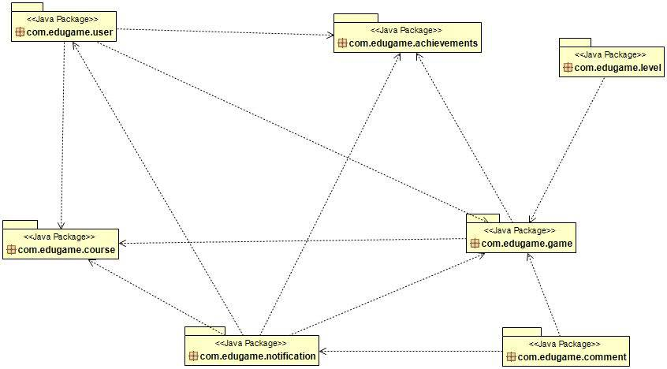

## Achievement

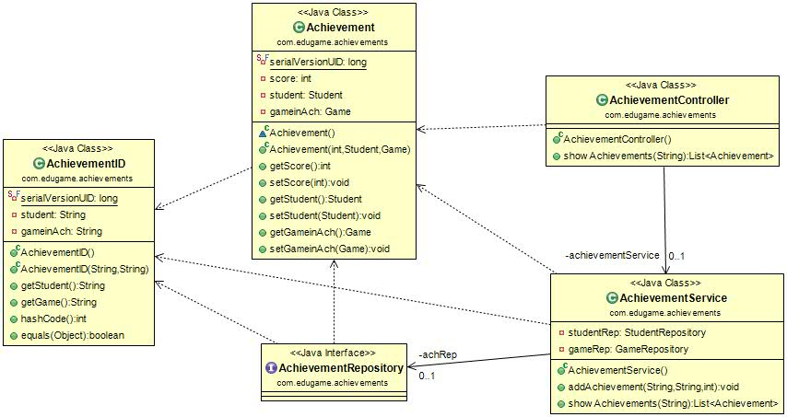

## Course

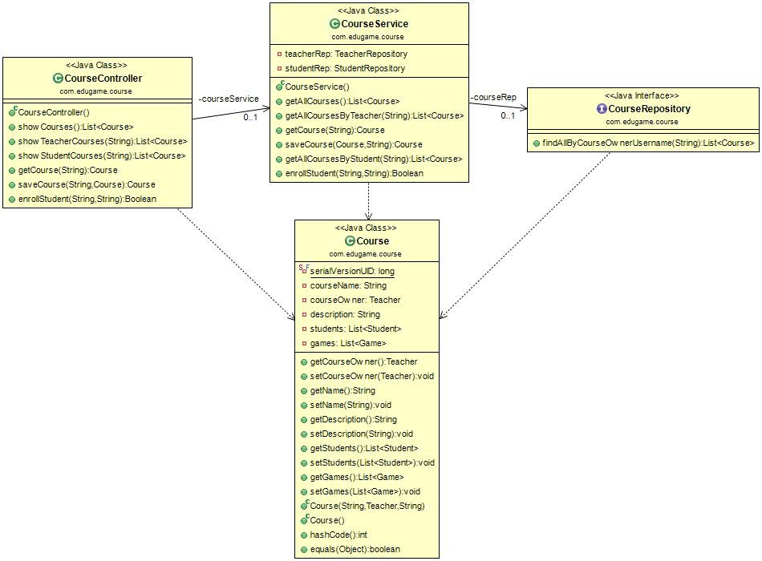

## Game

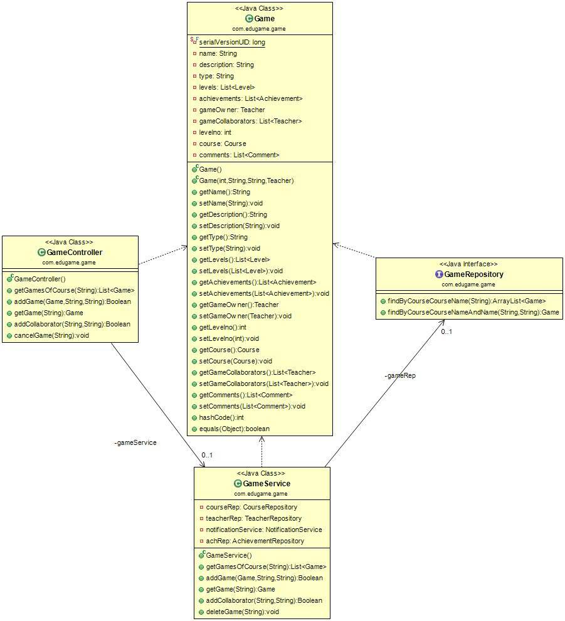

## Level

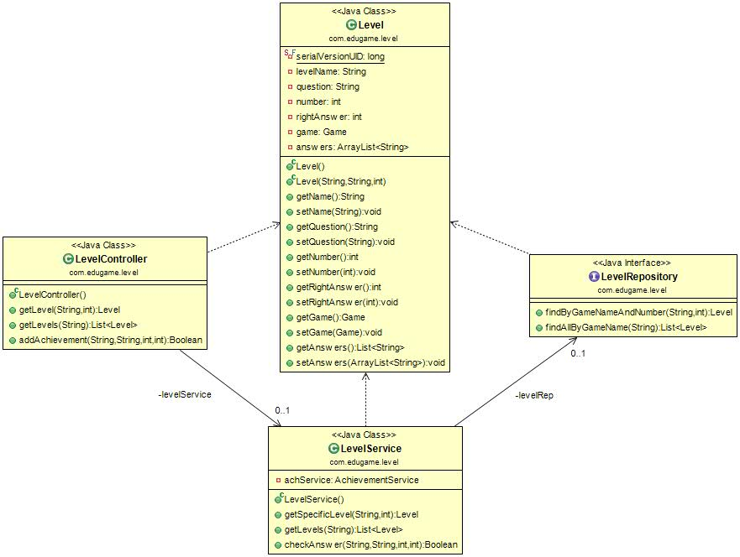

## User

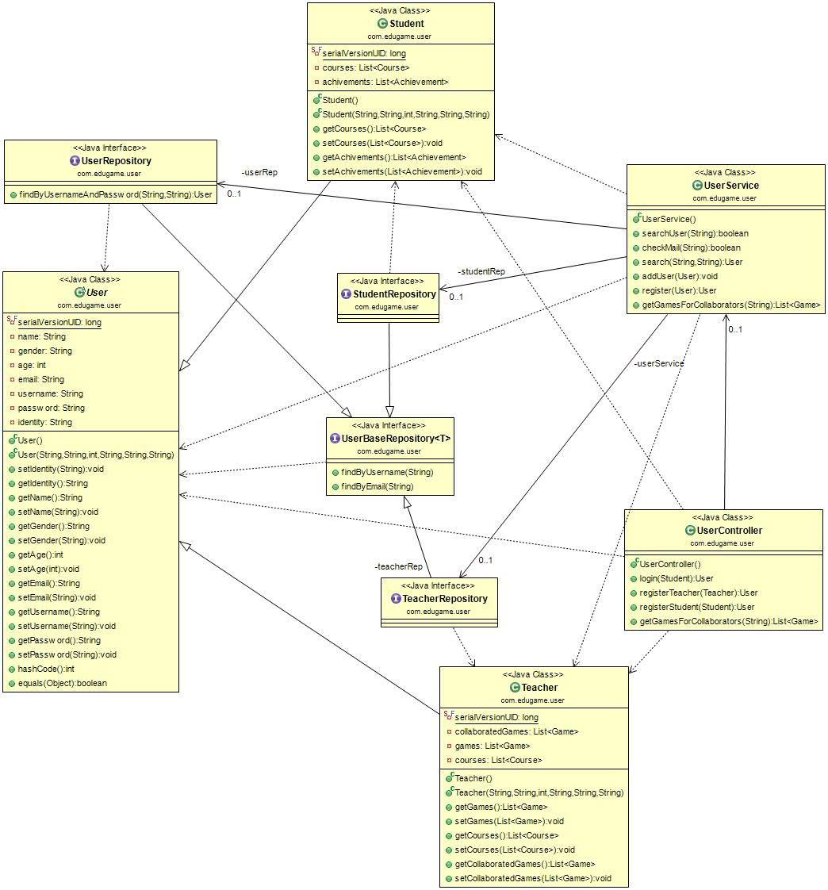

## Notification

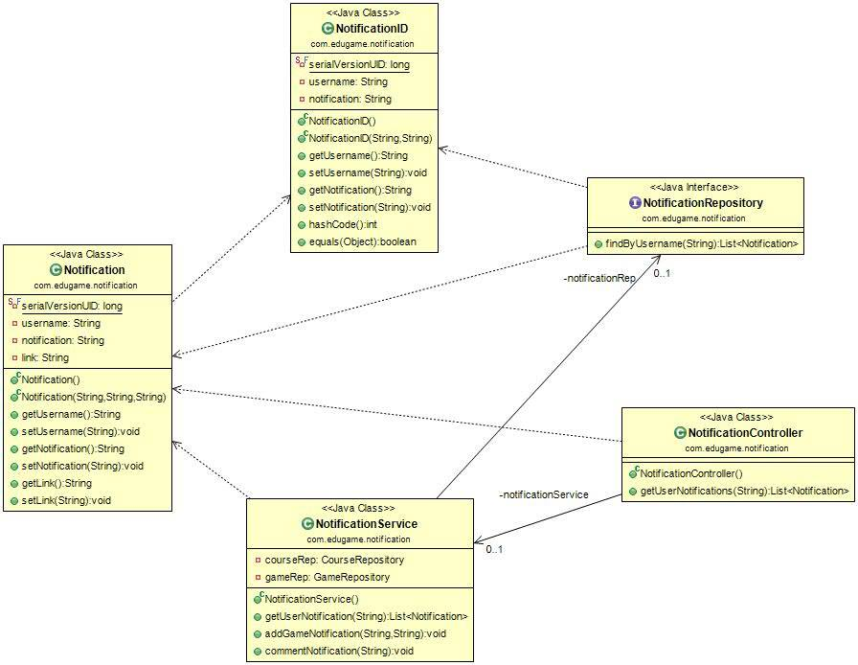

## Comment

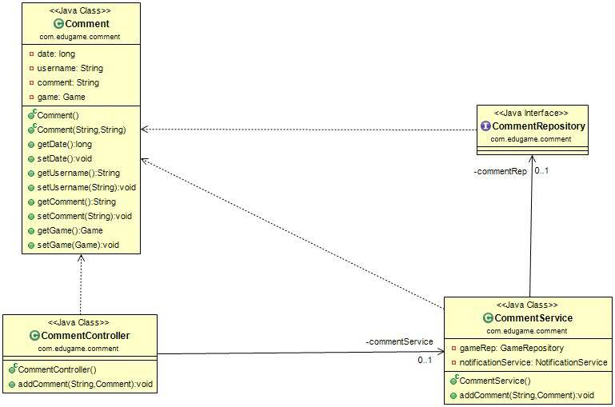

# Sequence Diagrams

## Register

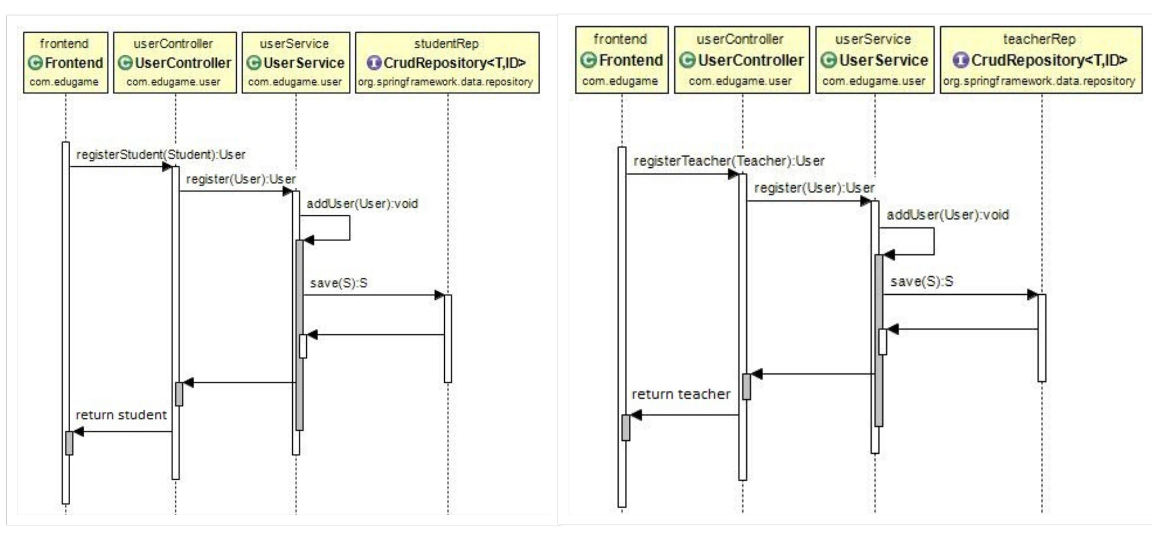

## Login

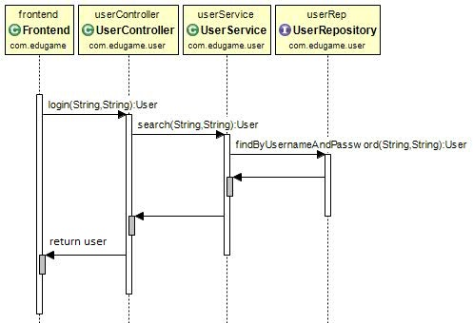

## Play Game

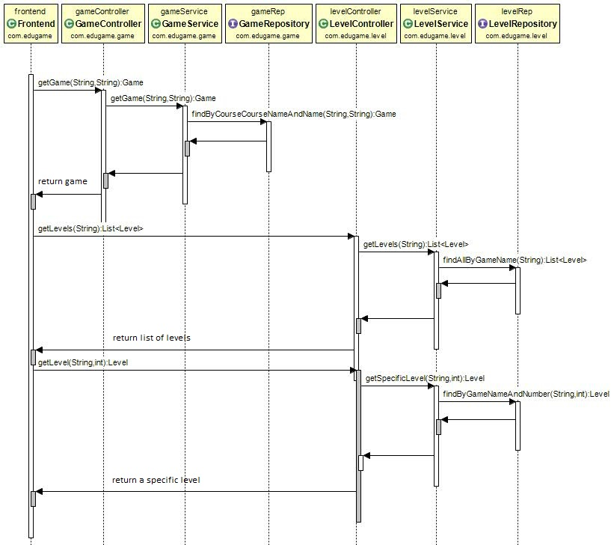

## Show Courses

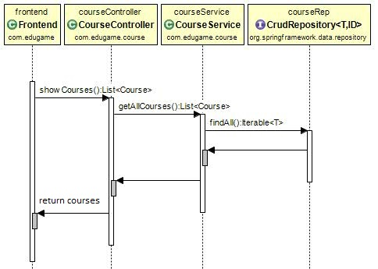

## Create Course

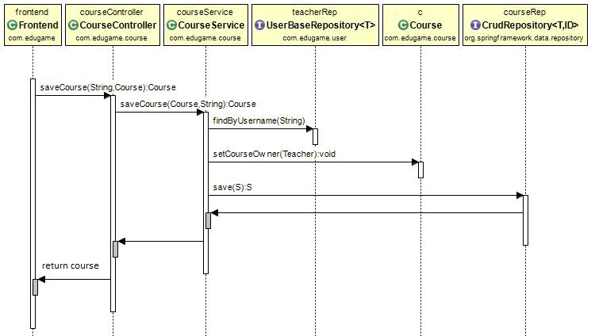

## Create Game

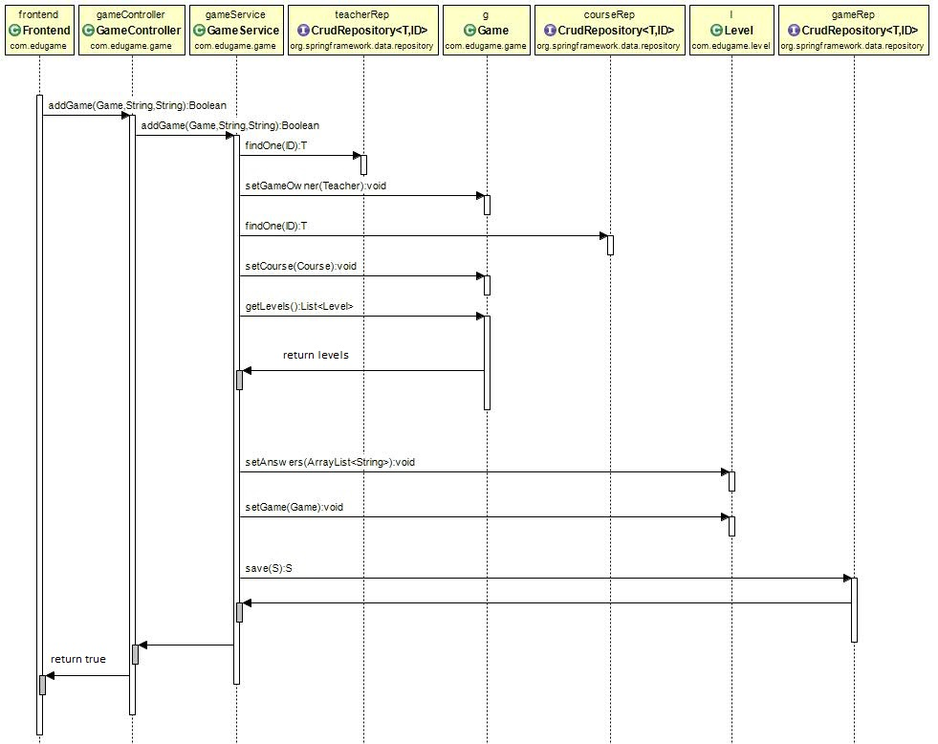

## Show Games in specific course

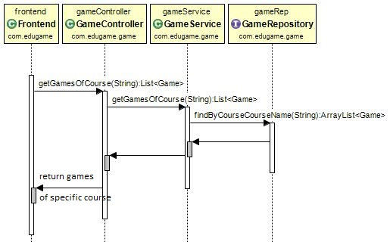

# Entity Relationship Diagram – ERD

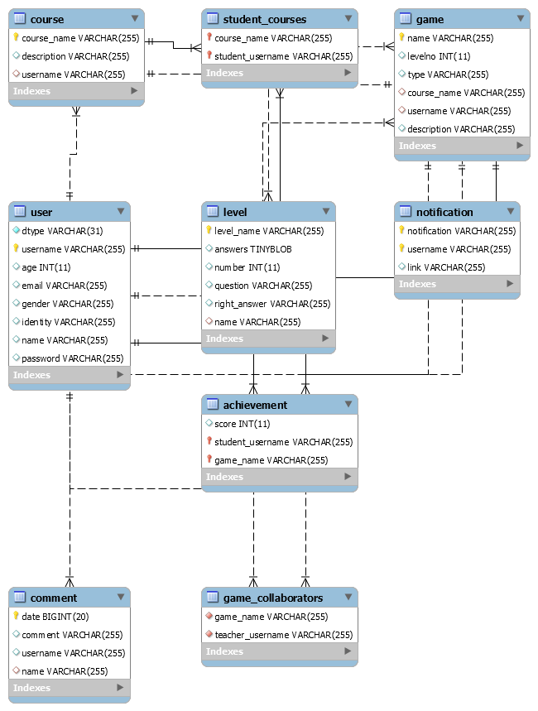

# Trello workspace screenshot

## Backend

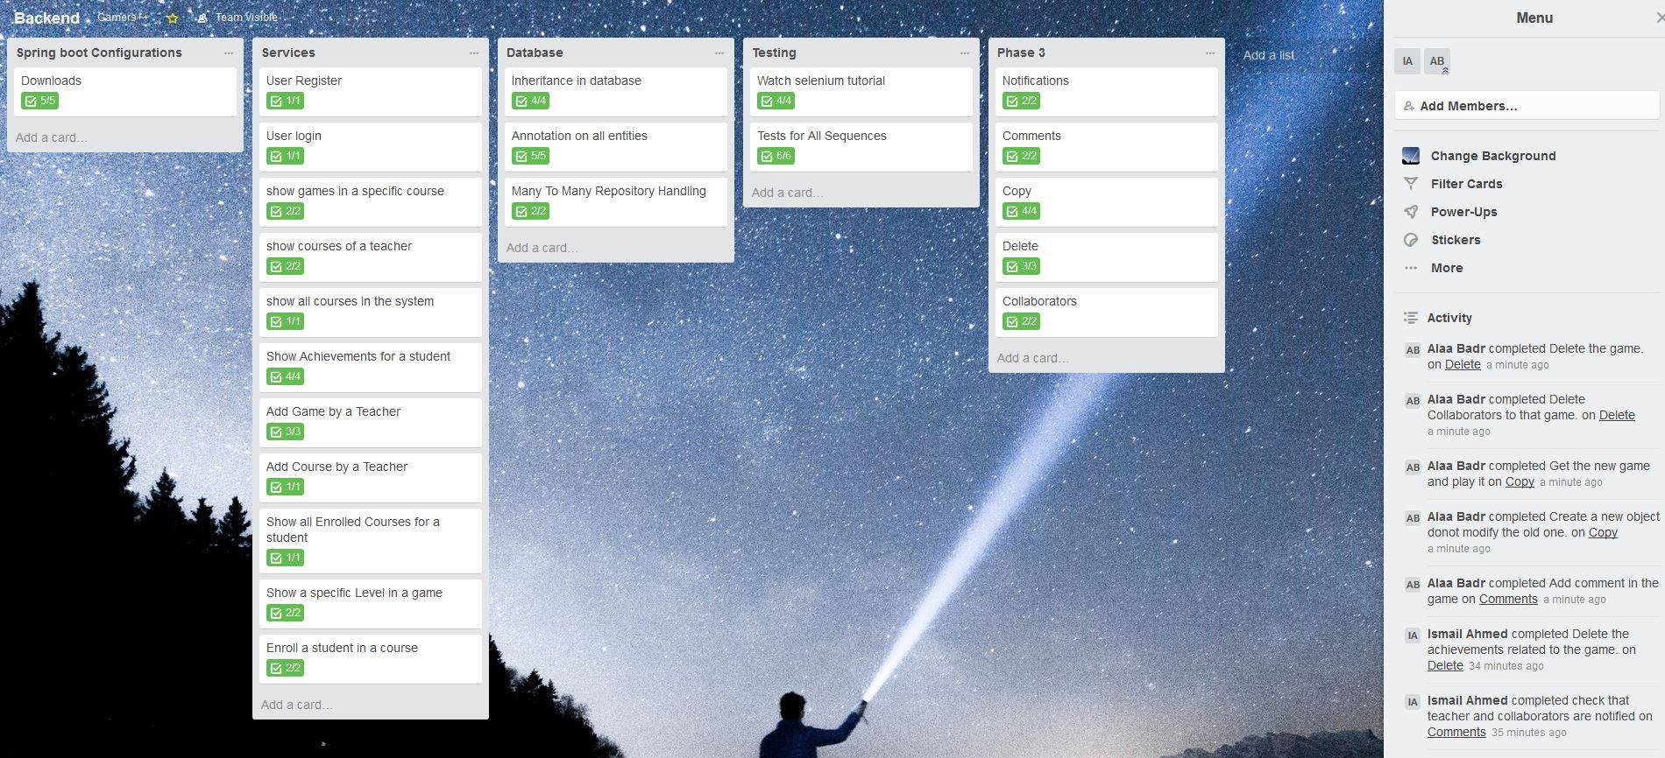

## Frontend

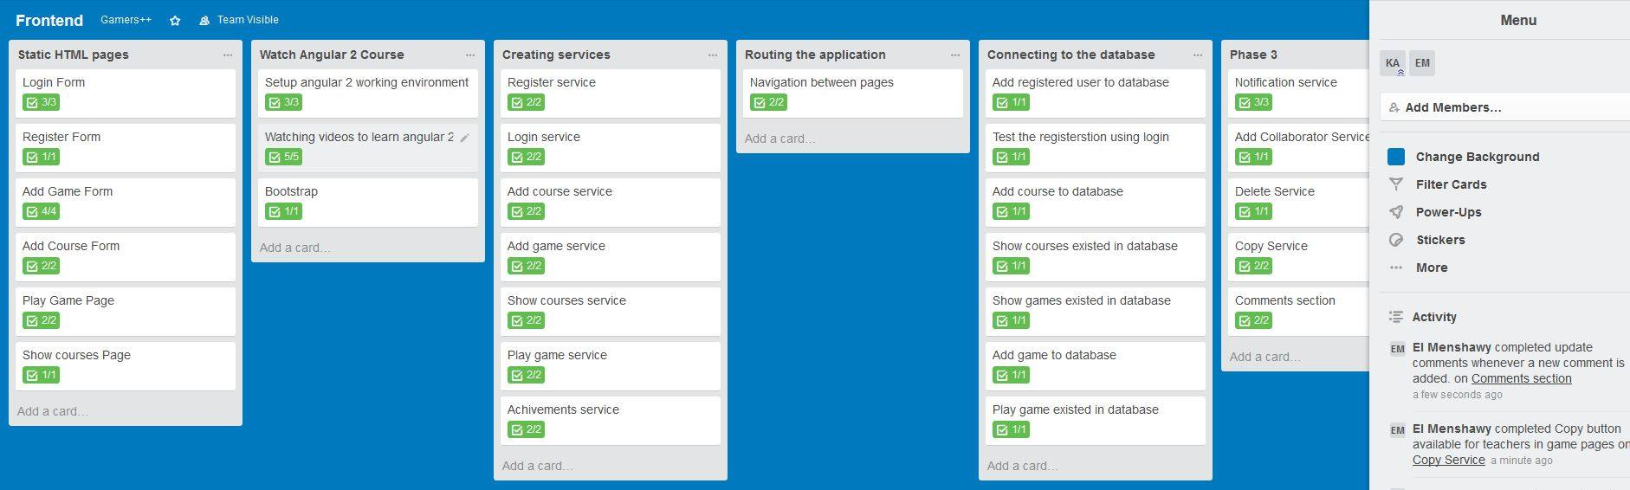

## Integration

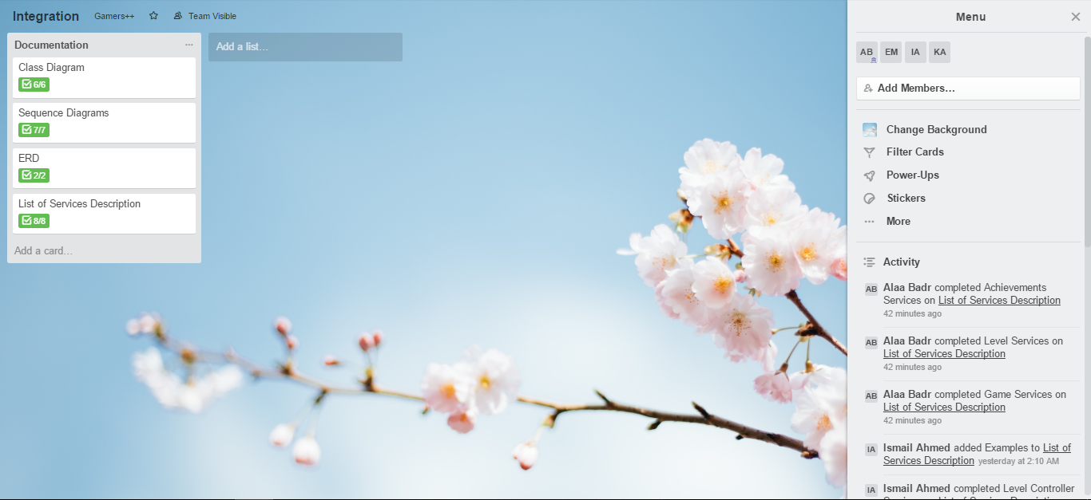

# Github repository link

***https://github.com/AlaaBadr/SWE2-Project***